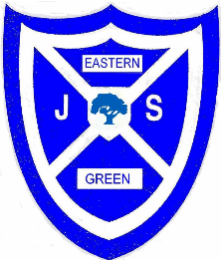

Eastern Green Junior School
School Terms and Holiday Dates 2025 – 2026

Term | Pupil Dates | Teacher Training Day
Autumn 2025 | Tuesday 2 September to  Friday 19 December | Monday 1 September
 | Half term Break  Saturday 25 October to  Sunday 2 November | Monday 3 November
Christmas Holiday
Saturday 20 December to
Sunday 4 January

Spring 2026 | Monday 5 January to  Friday 27 March | Friday 13 February
Half Term Break
Saturday 14 February to
Sunday 22 February

Easter Holiday
Saturday 28 March to
Sunday 12 April

Summer 2026 | Monday 13 April to  Friday 17 July
May Day Holiday
Monday 4 May
 | Half Term Break  Saturday 23 May to  Sunday 31 May | Friday 22 May
 | Summer Holiday Starts  Saturday 18 July | Monday 20 July

