Eastern Green Junior School’s expectations of
Parental/Carer’s behaviour and actions
- Respect the caring ethos of our schools
- Understand that both teachers and parents need to work together for the benefit of
their children.
- Demonstrate that all members of the school community should be treated with respect and therefore set a good example in their own speech and behaviour.
- Seek to clarify a child’s version of events with the school’s view in order to bring about a peaceful solution to any issue.
- Correct own child’s behaviour especially in public where it could otherwise lead to conflict, aggressive behaviour or unsafe behaviour.
- Approach the school to help resolve any issues of concern.


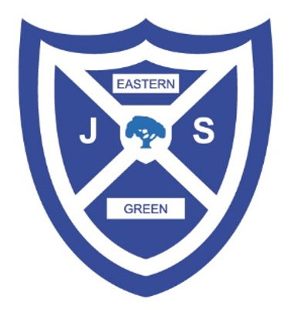

Parents Code of Conduct
RESPECT ● READY ● SAFE

Eastern Green Junior School

Sutton Avenue,
Coventry,
United Kingdom,
CV5 7EG

Headteacher: Mrs S Nealon
Assistant Headteachers: Mrs N Albans, Miss B Colbourne
We ask that parents…
- Treat all adults on school site with respect and show this
through your speech and behaviour.
- Do not use loud/offensive language or swear at any members of staff.
- Do not use or threaten physical force against any adult or child on school site.
- Do not approach other children or parents to resolve issues that have occurred in school or to discuss any issues between your child and another child.
- Always be a good role model to your child.

- Approach the school to
resolve any difficulties in a peaceful way.
- EGJS requests that all parents’ behaviour
reflects our core values
at all times, including when on social media websites, and that parents
act in the best interests of all children and the whole school community.

RESPECT
READY
SAFE

Please remember to…
- Speak to your child’s class teacher to share any concerns you have about your child’s learning or behaviour.
- Speak to a member of the Senior Leadership Team if you need pastoral support.
- Speak to the Headteacher or Assistant Headteachers if you have serious concerns about your child’s welfare.

Breaching the code of conduct
If EGJS suspects, or becomes aware, that a parent has breached our code of conduct, the school may then:
- Send a warning letter to the parent
- Invite the parent to school to meet with a senior member of staff or the Headteacher
- Contact the appropriate authorities (in cases of criminal behaviour)
- Seek advice from our legal team regarding further action (in cases of conduct that may be libellous or slanderous)
- Ban the parent from the school site

