Welcome to Our School!
Changing schools can cause concern for children and parents and small things can become a large problem in the mind of a child. In every case, the child’s wellbeing is uppermost in our minds. If there is a problem that needs discussing, please do not hesitate to contact us. In the meantime, we hope that this information is helpful in answering some of your questions!

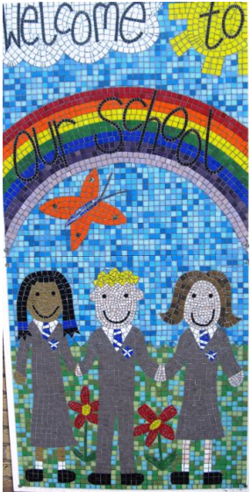
Contact details:
Eastern Green Junior School,
Sutton Avenue,
Coventry,
CV5 7EG

Tel: 024 76465077
E-mail: admin@easterngreen.coventry.sch.uk

Headteacher: Mrs Sara Nealon
Chair of Governors: Mr Ian Hawkswood
School Business Manager: Mrs Fiona Dodds
Office Staff: Mrs Nicky Reading/ Miss Laura Johnson

The School Day
School session times are:
9.00am -12.00noon
1.00pm -3.30pm
The school gates are opened at 8.45am and children come straight into school and into their classroom when they arrive. We cannot accept responsibility for children who arrive before that time, unless they are attending a before school club. The front and back gates are supervised from 8.45-9.00am every day. For everyone’s safety, parents are asked not to drive onto the school car park at any time before, during or after the school day. Please also be considerate of our neighbours, other road users and pedestrians as you drop off your children and/or wait outside of the school to pick them up. This applies to both the Sutton Avenue and Mellowship Road gates.
If circumstances beyond your control mean that you are late picking up your child, please contact the School Office before 3.30pm and your child will be kept safely in school until you arrive. We make sure that the children know to come straight back into school if there is no one there to collect them at the end of the school day and ask that you emphasise this with your children too.
We allow children to store their bikes and helmets in our secure, covered cycle racks if they choose to cycle to school. The responsibility of the journey to school lies with parents however, and for the safety of our children we urge parents to accompany those children who have not taken part in Cycling Training offered by the school in Year 5.

Attendance
Regular attendance is vital to sustained progress and positive friendships. It is important that we are all aware of where every child is during the school day. Therefore we ask that you make a telephone call or send an e-mail to school on the first day of absence to explain the reason for your child’s non-attendance, whatever the cause. To ensure the safety of our children, if we have not received any notification of absence from parents/carers by approximately 10am we will call you to confirm the reason.
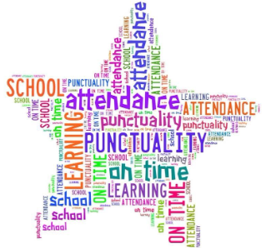
Holidays during term time will not be authorised under any circumstances. Absences will only be authorised when a child is ill or in exceptional family emergencies.
At the end of each academic year, the attendance of each child is reported to parents. Attendance concerns will be raised with parents earlier when the figure falls below 90% and external agencies may be involved. We have outstanding attendance -our whole school attendance figure usually averages between 96- 97%.

Medication
Inhalers can be left in school for use by children, but these should be given to the Class Teachers to be kept safely. Special medical kits for children with severe allergies should also be left in the school office with a Care Plan and clear instructions as to their use. Children may bring medication to school, but parents must complete a consent form, available from the school office. Children will be supervised taking medication; parents are not required to be present.

Collecting Children during the School Day
Children who leave school during school hours must be collected by parents, or a named, responsible adult, and signed out at reception. Please inform the Office in advance if you need to take your child out of school. Medical appointments during school hours should be avoided where possible.

Safeguarding Your Children
Eastern Green Junior School is committed to safeguarding and promoting the welfare of your children. All visitors are required to sign in at Reception and are asked to provide identification. On that basis we urge parents or anyone else who picks your child up from school to enter school only via the front entrance by the Offices if you need to speak to a member of staff, after or before school, so that we are aware that you are in our building. Staff are under instruction to approach anyone they do not recognise who are in and around the school unsupervised and if this occurred we would hope that you would respect them in their duty to keep every child safe.

Lunchtime
At lunchtime, children may either have a school lunch or they may bring a packed lunch. We provide a varied menu of healthy and nutritious school meals, catered for by Chartwell’s catering service. Payments for school meals should be done in advance using our online payment system, ‘MCAS. We encourage those children who do not have a school dinner to bring a healthy, nutritious packed lunch- no glass bottles or cans please.

Breaktime snacks
Children are allowed to bring a breaktime snack. We request that children bring only fruit or prepared vegetable snacks for break times, preferably in a reusable plastic container to minimise waste.

School Clubs
There are a vast range of before and after school clubs which the children may wish to be involved in. Details of how to join will be provided at the start of each term. Parents need to ensure children are aware of the arrangements in place regarding how they will be picked up once the club is finished. There are occasions where a club has to be cancelled at short notice- in this case, you will receive a telephone call or text message, and alternative arrangements will need to be made for your children.

Talking to the Teachers
Throughout the academic year there are two Parents’ Evenings where you have the opportunity to talk to your child’s Class Teacher about the progress, effort, attitude and behaviour of your child. These occur in each of the first two terms. In the Summer Term you will receive a written report. However, we appreciate there are other times when you will need to talk to your child’s class teacher. You can also contact the School Office via phone or email if you need to talk to a teacher; they may see you straightaway or will call to arrange an appointment as soon as is possible.

Curriculum and Entitlement
We teach a broad and balanced curriculum, yet place a high emphasis on developing basic maths and English skills to ensure children are well prepared for the next stage of their education. Children learn many of the foundation subjects through topics- a new topic will be covered each term. Children also have the opportunity to learn about a range of different cultures and faiths in Religious Education and we have a daily assembly which supports our RE and Personal, Social and Health Education curriculum. Parents have the right to withdraw their children from such education or worship and can do so in consultation with the Headteacher.

Homework
Our homework consists of regular reading, spellings and practice of maths skills. The children are expected to read for 10 minutes, 5 times a week. This must be recorded in their reading diary. They may read to someone else or to themselves. We also ask that parents support and encourage children to learn their times tables and weekly spellings. Teachers will let the children know which times table they should focus on and this is tested at school to check they are making progress and learning at home too. Spelling lists are also handed out weekly. We ask that children are given every encouragement at home to complete their reading, spelling and maths.

Educational Visits and Visitors
Educational visits and visitors are used throughout the school to widen the children’s experiences. In accordance with legal requirements, any payments for such visits are voluntary. Consequently, if there is insufficient financial support for an arranged visit, it may be cancelled.

PTA
The school has an active PTA which is always on the lookout for new members. The support of parents to raise money for the children is invaluable and we have held many successful events. Current members of the PTA can be contacted via the School Office.

Emergency Closure
Once school has opened it would normally remain open throughout the day. In adverse weather conditions we would use the local radio snowline, the Coventry City Council website, the school e-mail service and our school Facebook page to inform parents of any situation necessitating closure. In an emergency requiring evacuation of the building we have an arrangement in place whereby our children will be accommodated at St Andrew’s CE Infants until such time that parents can be contacted.

Communication
To aid effective communication we use an online email system- this allows us to send messages to parents via text messaging and also to e-mail important information. You will be signed up for this when your child starts at Eastern Green. We also have a school Facebook page where we celebrate the children and their achievements but also share important information.
Newsletter
Our Friday newsletter, packed full of important dates, information and events is sent out to parents on a weekly basis. Our aim is to reduce the amount of letters sent home, therefore, the newsletter contains information regarding whole school, year group and class news. Please ensure that you read the newsletter so as not to miss out on information regarding your child and school life. The Newsletter can be e-mailed or sent home as a paper copy.
Uniform (see additional information)
We have a uniform which children are expected to wear. Ties can be purchased from the school. Children will receive their first tie free of charge. Other items of uniform can be purchased from local suppliers. The wearing of jewellery is discouraged and if children have pierced ears they should only wear studs. Items of clothing should be clearly labelled to avoid vast amounts of lost property - labelling, if only by writing in biro on the washing instructions tag, is extremely helpful!

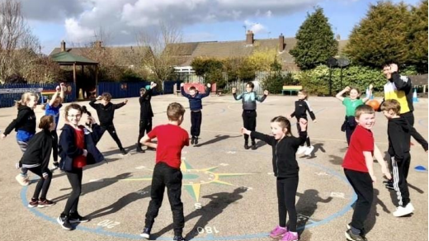
PE Kit
On the days that they have their PE and Games lesson, the children are expected to wear their PE kit for school all day. We have an Eastern Green tracksuit. Otherwise children must wear plain navy or black joggers/ tracksuit bottoms and a navy/ black sweatshirt or hoodie. Each child will need a sports t-shirt in their house team colour. Appropriate sports footwear is also required. If there is an occasion where your child cannot take part in PE, we expect a note or message from parents to confirm this. PE is a National Curriculum subject and children should only be exempt in exceptional cases.

Music Lessons
We offer music tuition for a range of instruments. The cost of the tuition has to be met by parents and in advance. Tuition is open to all children in school and lessons take place during school time.

House Teams
We encourage the children to be proud of their school and a house system is in place to help us in this:
Curtis – green
Merrick – yellow
Neal – blue
Stafford – red
Children gain housepoints for a range of reasons and the winning house team is announced weekly in assembly. Children have regular house meetings and get an opportunity to compete for their houses in Sports Day.

Celebration Assemblies
Every Friday in our assembly we celebrate the good work, behaviour and achievements of children throughout our school. This is a chance for the school community to come together and share each other’s successes.

